Bürde KESİKBAŞ

Case Study: Online Recipe Platform

**Recipe Search and Filtering Test Scenarios:**

**1.Test Scenario Name: Listing Recipes by Selecting a Specific Category**

**Description:** This test is designed to verify the functionality of listing recipes based on selected categories on the Recipe Platform website. It ensures that users can filter recipes according to their desired specifications.

**Preconditions:** The test environment must be operational and ready.

**Case 1: Checking the Listing of Recipes by Selecting a Category**

**Description:** This test verifies the ability of users to click on the "Tarifler" section to list recipe categories and subsequently display recipes based on the selected categories. **Preconditions:** The test environment must be operational and ready.

**Steps:**

1. Open the web browser.
2. Go to the URL:<https://www.nefisyemektarifleri.com/>
3. Click on the "TARİFLER" (Recipes) section on the homepage.
4. Click on one of the listed categories.

**Input:** Aperatifler

**Expected Result:**

* The page URL should change to "<https://www.nefisyemektarifleri.com/kategori/tarifler/aperatifler-tarifler/>".
* Appetizer recipes should be displayed by default, sorted by popular recipes.

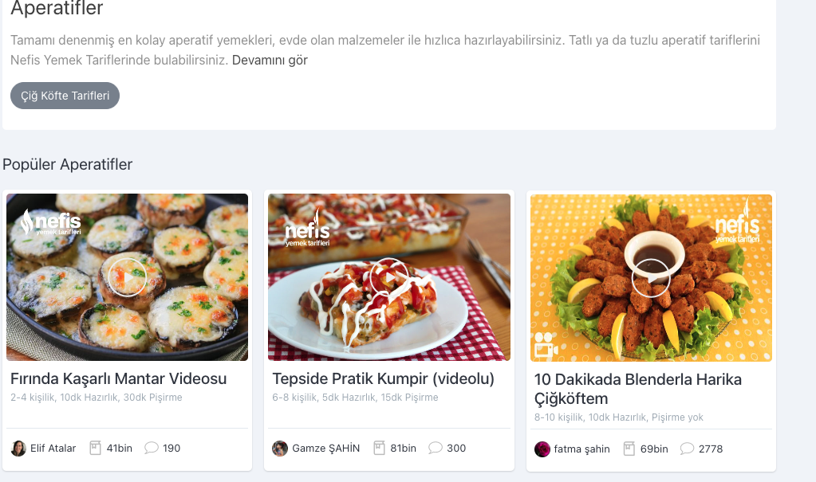

**Case 2: Verifying Listing of Categories by Clicking on "All Categories" in the Dropdown When Hovering Over the "Recipes" Header**

**Description:** This test verifies the functionality where users can hover over the "Tarifler" section, click on "Tüm Kategoriler" in the dropdown that appears, list recipe categories, and subsequently display recipes based on the selected categories.

**Preconditions:** The test environment must be operational and ready.

**Steps:**

1. Open the web browser.
2. Go to the URL:<https://www.nefisyemektarifleri.com/>
3. Hover over the "TARİFLER" (Recipes) header on the homepage.
4. Click on "Tüm Kategoriler" (All Categories) in the dropdown that appears.
5. Click on one of the listed categories.

**Input:** Aperatifler

**Expected Result:**

* The page URL should change to "<https://www.nefisyemektarifleri.com/kategori/tarifler/aperatifler-tarifler/>".
* Appetizer recipes should be displayed by default, sorted by popular recipes.



**Case 3: Verifying Listing of Recipes by Selecting a Category from the "Tarifler" Section at the Bottom of the Page**

**Description:** This test verifies the functionality where users can click on the "Tarifler" section at the bottom of the page to list recipe categories and subsequently display recipes based on the selected categories.

**Preconditions:** The test environment must be operational and ready.

**Steps:**

1. Open the web browser.
2. Go to the URL:<https://www.nefisyemektarifleri.com/>
3. Scroll down to the bottom of the page.
4. Click on the "Tariflerim" section.
5. Click on one of the listed categories.

**Input:** Aperatifler

**Expected Result:**

* The page URL should change to "<https://www.nefisyemektarifleri.com/kategori/tarifler/aperatifler-tarifler/>".
* Appetizer recipes should be displayed by default, sorted by popular recipes.



**2. Test Scenario Name: Listing Recipes by Selecting a Specific Ingredient**

**Description:** This test is designed to verify the functionality of listing recipes based on selected ingredients on the Recipe Platform website. It ensures that users can filter recipes according to their desired ingredients in the search field.

**Preconditions:** The test environment must be operational and ready.

**Case 1: Verifying Recipe Listing by Searching for an Ingredient in the Search Section**

**Description:** This test verifies the ability of users to click on the search field on the homepage and list recipes based on the ingredient they want in the recipe.

**Preconditions:** The test environment must be operational and ready.

**Steps:**

1. Open the browser.
2. Go to the URL:<https://www.nefisyemektarifleri.com/>
3. Click on the search field on the homepage.
4. Type the name of the ingredient you want to search for in the recipe.

**Input:** Peynir

1. Click on the search button.

**Expected Result:** Recipes containing "peynir" in their content should be listed. There should be a filtering area on the left side of the recipes.

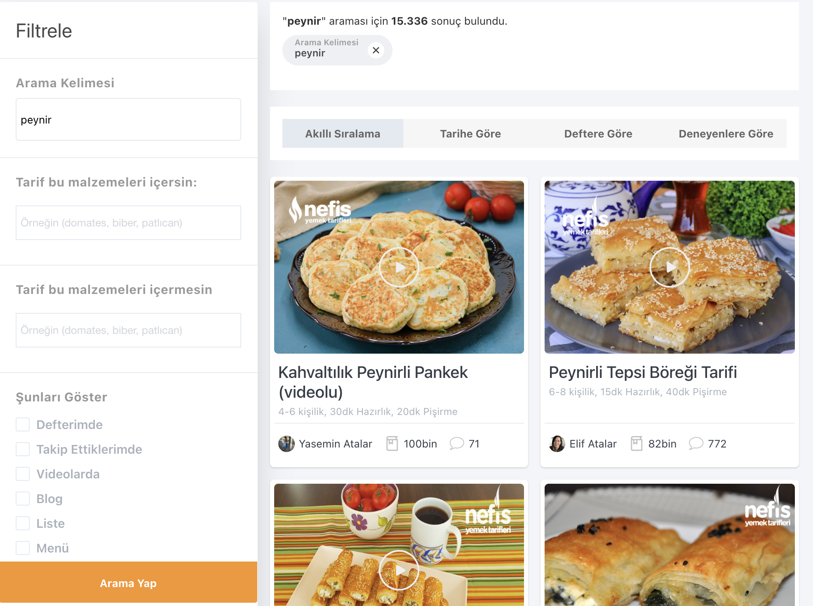

**Case 2: Verifying Ingredient Filtering Area by Clicking on the Search Icon**

**Description:** This test verifies the functionality where users can click on the search icon to access filtering options based on ingredients they want or do not want in recipes.

**Preconditions:** The test environment must be operational and ready.

**Steps:**

1. Open the browser.
2. Go to the URL:<https://www.nefisyemektarifleri.com/>
3. Click on the search icon on the homepage.

**Expected Result:** The filtering area should include sections titled "Tarif bu malzemeleri içersin:" and "Tarif bu malzemeleri içermesin:". These sections allow users to specify ingredients they want or do not want in the recipes.

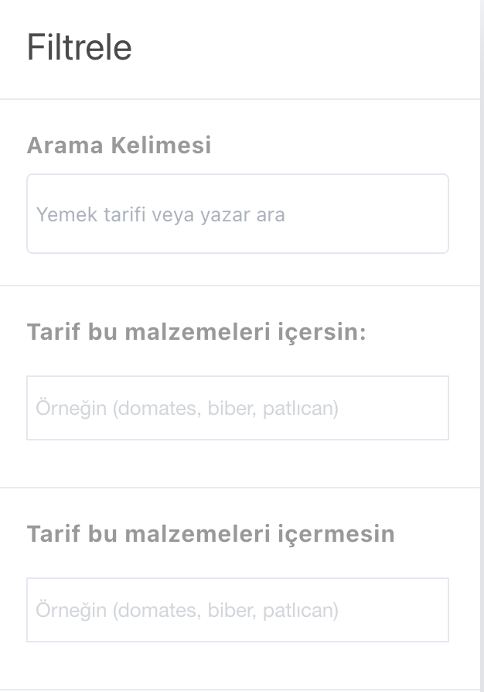

4. Click on the area titled "Tarif bu malzemeleri içersin:" and type the ingredient you want to include in the recipe.

**Input:** Peynir

1. Click Enter.
2. Click on the area titled "Tarif bu malzemeyi içermesin:" and type the ingredient you do not want to include in the recipe.

**Input:** Maya

7. Click Enter.

8. Click on the "Search" button.

9. Click on one of the recipes.

**Expected Result:** Recipes should be listed that contain "peynir" in their content and do not contain "maya" in their content.

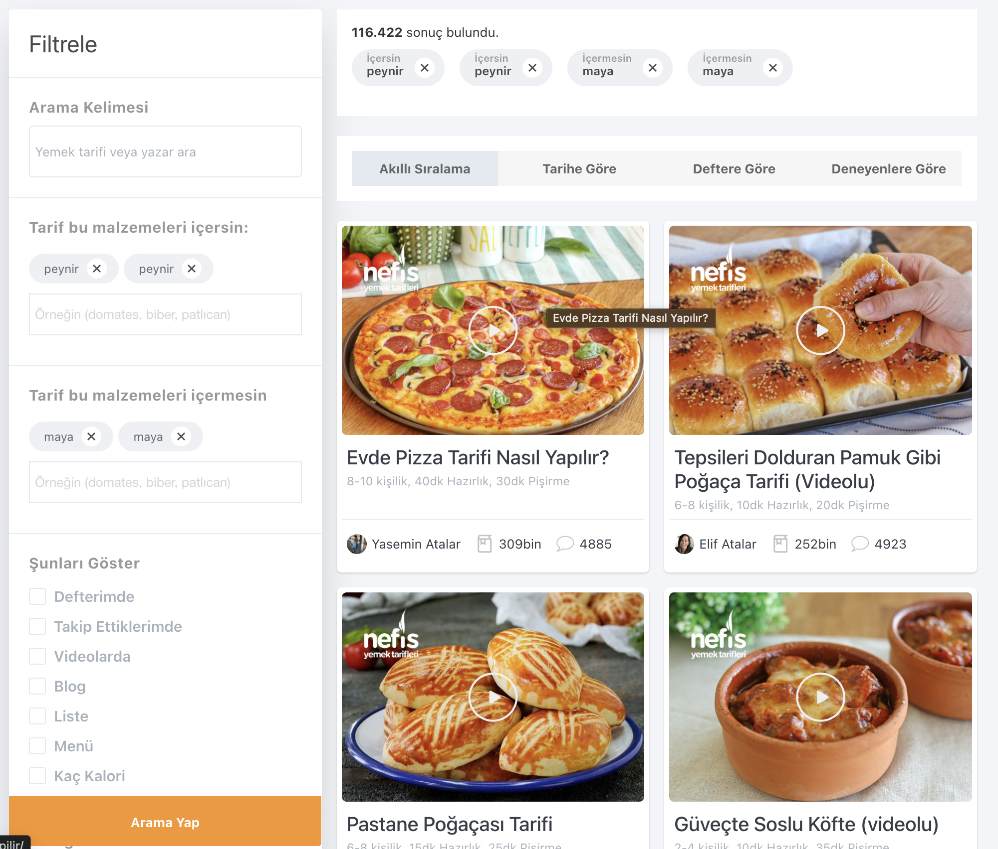

**Test Scenario 3: Searching Among Recipes and Correctly Filtering Results**

**Description:** This test is created to verify the process of searching among recipes on the cooking recipes website and correctly filtering the results based on the specified criteria.

**Preconditions:** The test environment must be operational and ready.

**Case 1:** **Verifying Correct Recipe Listing by Entering a Recipe Name in the Search Area**

**Description:** This test will verify that the correct recipe can be listed by entering a recipe name in the search area.

**Preconditions:** The test environment must be operational and ready.

**Steps:**

1. Open the browser.
2. Go to the URL:<https://www.nefisyemektarifleri.com/>
3. Click on the search area on the homepage.
4. Enter the name of the recipe you want to list.

**Input:** Karnıyarık

1. Click on the search icon.

**Expected Result:** Recipes related to "Karnıyarık" should be listed.

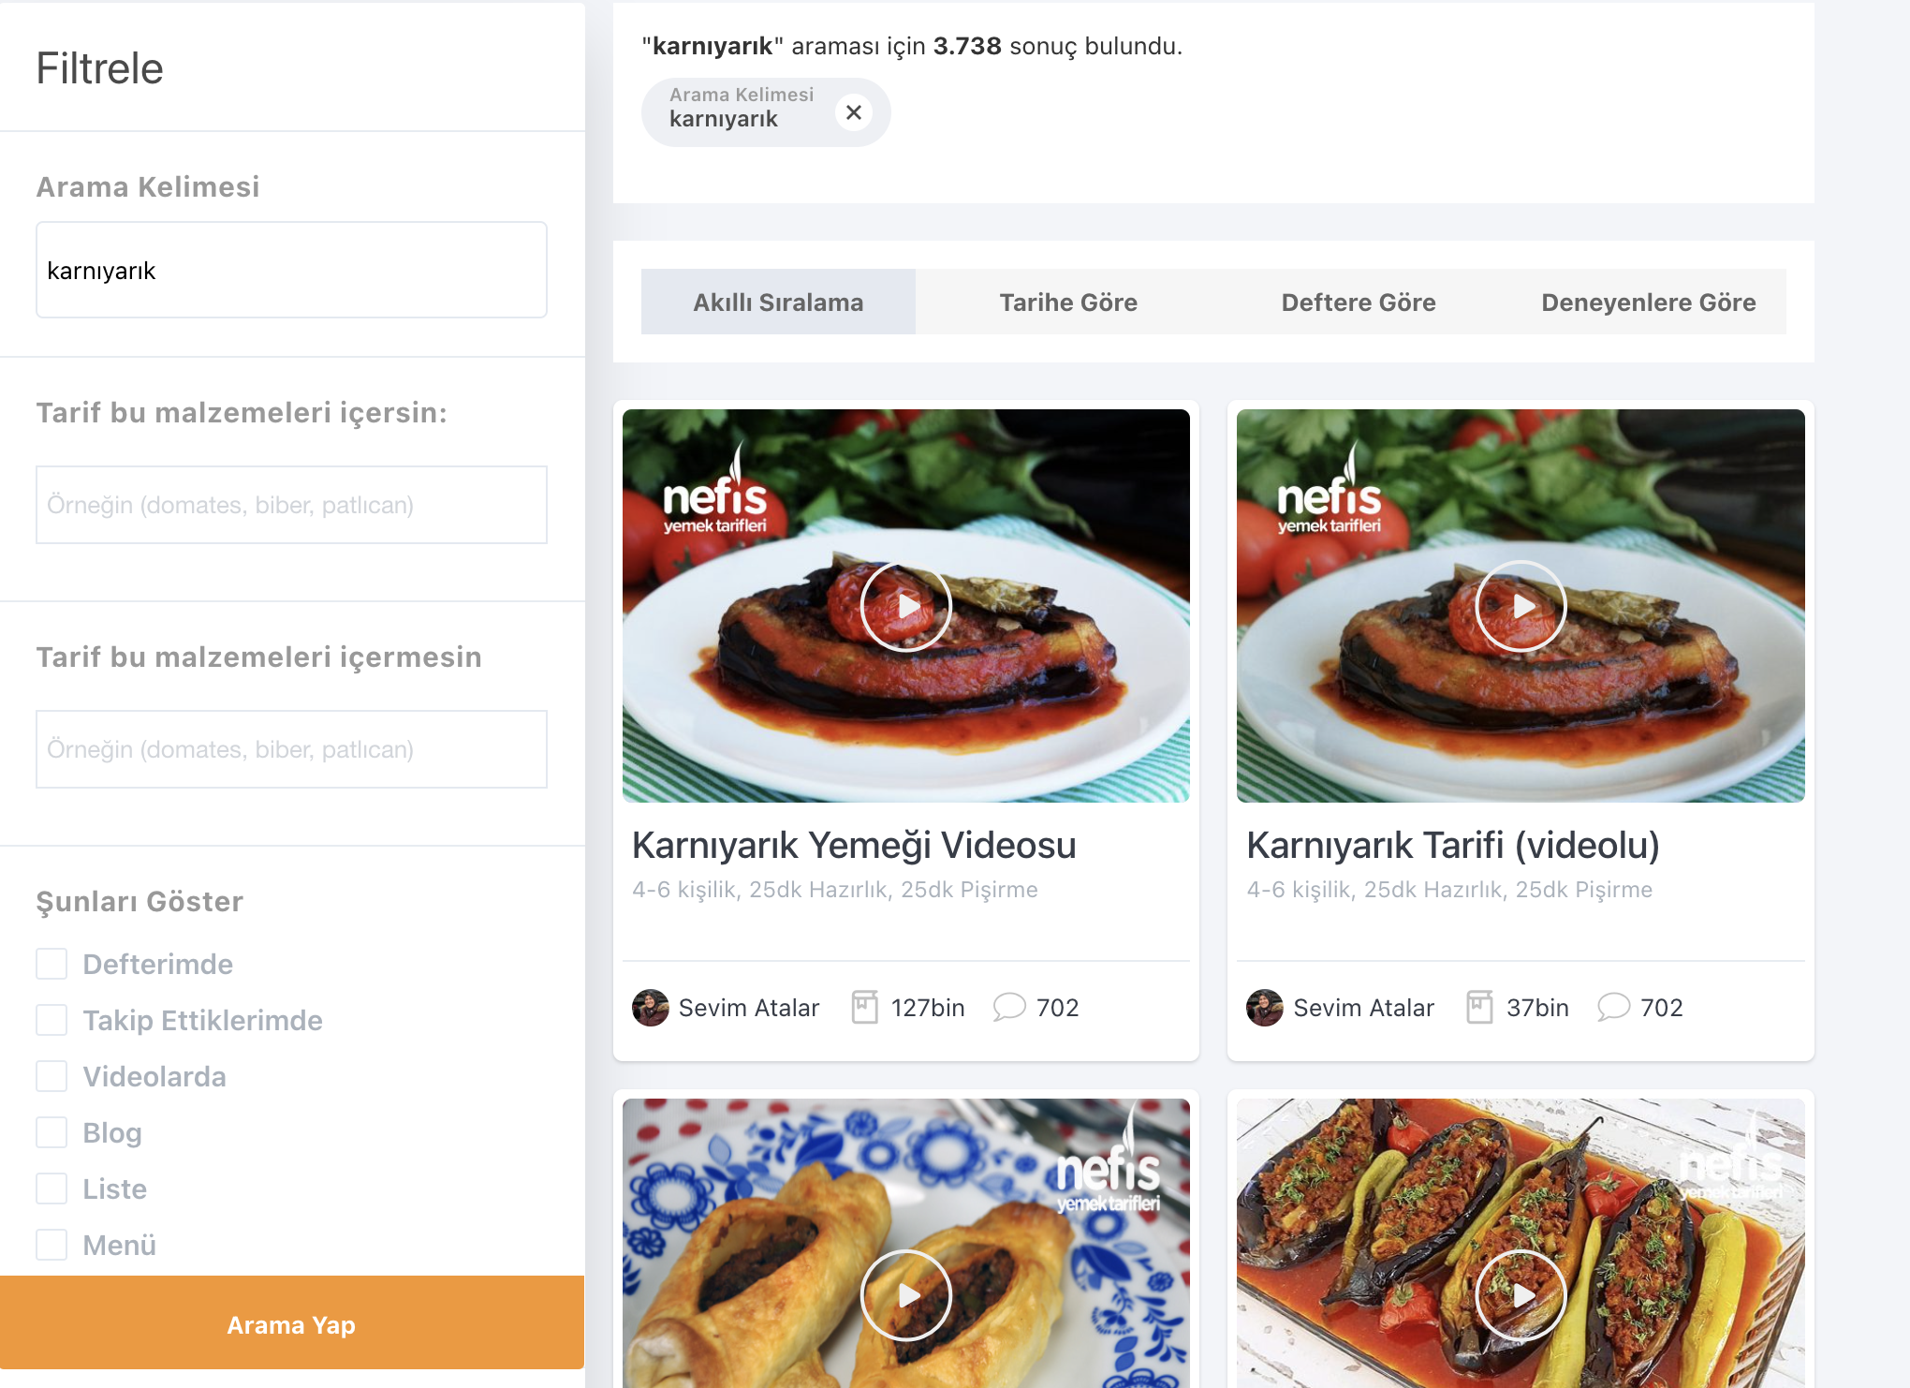

### **Case 2: Verifying Recipe Filtering and Accuracy by Clicking the Search Icon**

**Description:** This test will verify the accuracy of the recipe filtering by clicking the search icon and applying filters on the resulting page.

**Preconditions:** The test environment must be operational and ready.

**Steps:**

1. Open the browser.
2. Go to the URL:<https://www.nefisyemektarifleri.com/>
3. Click on the search icon on the homepage.
4. Scroll down the opened page.
5. Click on the "Tüm Tarifler" title under the Categories section.
6. In the "Arama Kelimesi" field, enter the recipe you want to search for.

**Input:** Karnıyarık

1. Click the "Arama Yap" button.

**Expected Result:** Recipes related to "Karnıyarık" should be listed.



### **Test Scenario 4: Ensuring Accurate Display of Recipe Content and Ingredient List on the Recipe Detail Page**

**Description:** This test verifies that when navigating to a recipe's detail page on the recipe platform, the recipe content and ingredient list are accurately displayed.

**Preconditions:** The test environment must be operational and ready.

#### **Case 1: Verifying the Accuracy of the Desired Recipe's Detail Information**

**Description:** This test checks the accuracy of the recipe content and ingredient list by viewing the details of a specific recipe.

**Preconditions:** The test environment must be operational and ready.

**Steps:**

1. Open the browser.
2. Go to the URL:<https://www.nefisyemektarifleri.com/>
3. Click on the "TARİFLER" section.
4. Click on one of the recipe categories.

**Input:** Bakliyat Yemekleri

5. Click on one of the recipes.

**Input:** İçli Köfte Recipe

**Expected Result:** The page should display the recipe details and ingredient list for the "İçli Köfte" recipe accurately.

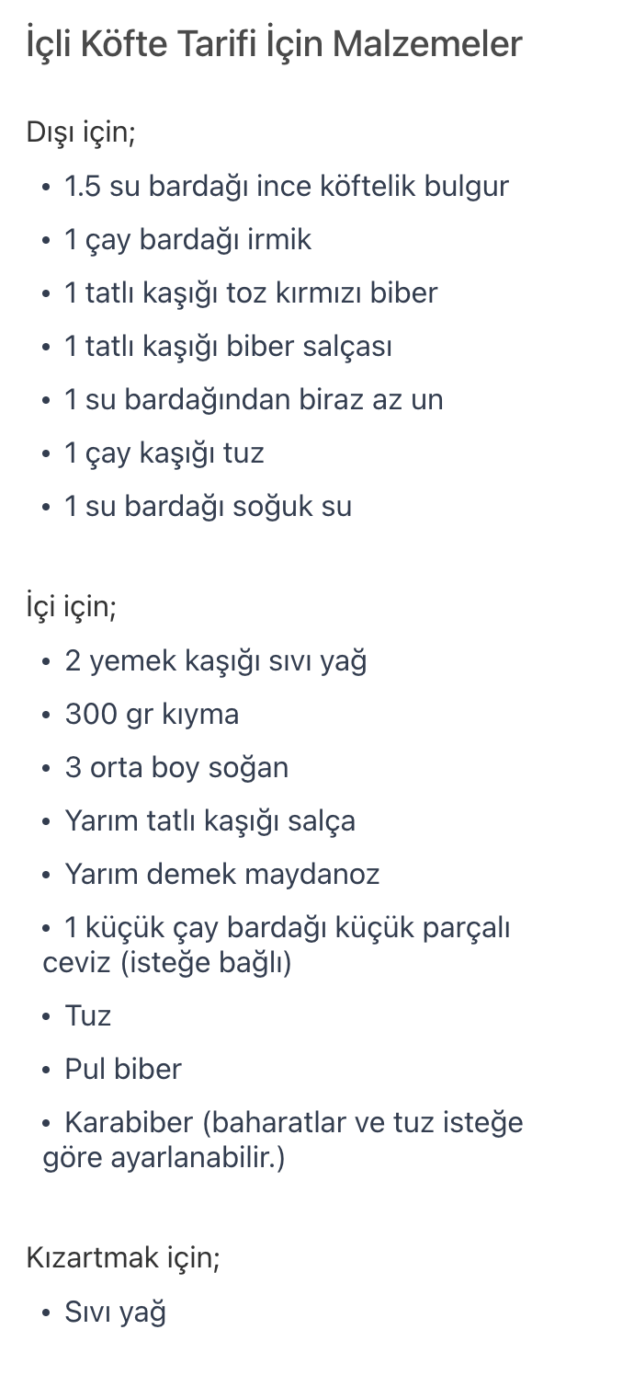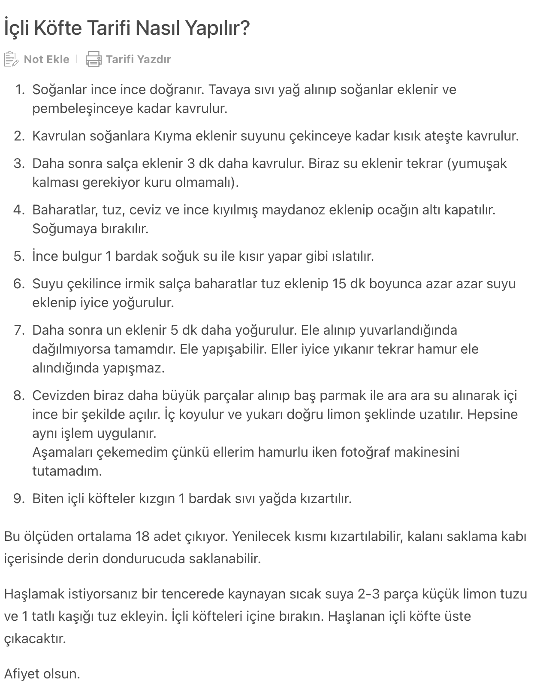

### **Recipe Commenting and Saving Test Scenarios:**

**Test Scenario 1: Adding a Comment to a Recipe and Verifying the Comment is Saved Correctly**

**Description:** This scenario will verify that a user can add a comment to a recipe on the Recipe Platform and that the comment is saved correctly.

**Preconditions:** The test environment must be operational and ready.

**Case 1: Verifying the Ability to Comment on a Recipe Without Logging In**

**Description:** This case will test whether a user can comment on a recipe on the website without logging in.

**Preconditions:** The test environment must be operational and ready.

**Steps:**

1. Open the browser.
2. Go to the URL:<https://www.nefisyemektarifleri.com/>
3. Click on the "TARİFLER" heading on the homepage.
4. Click on one of the listed categories.

**Input:** Bakliyat Yemekleri

1. Click on one of the listed recipes.

**Input:** İçli Köfte Tarifi

1. Click on the "Yorumlar" heading below the recipe image.
2. Scroll down the page.

**Expected Result:** The comment section should display the message "Yorum yapabilmek için giriş yapmanız gerekmektedir." and should not allow commenting.

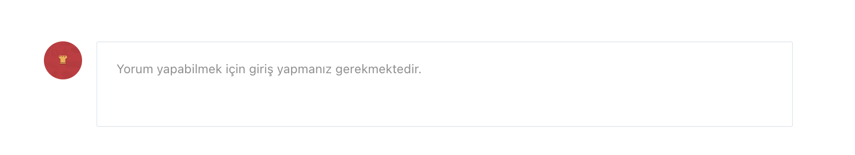

**Case 2: User Login to Comment on a Recipe and Save it**

**Description:** This test verifies that a user with an existing account can log in to the recipe website, comment on a recipe, and ensure that the comment is saved successfully.

**Preconditions:** The test environment must be operational and ready.

**Steps:**

1.Open the browser.

2.Go to<https://www.nefisyemektarifleri.com/> URL.

3.Hover over the "Giriş Yap" icon.

4.Click on the "Giriş Yap" title.

5.Click on the desired login method.

**Input:** E-posta ile Giriş Yap

6.Enter the username or email address in the Username / Email field.

**Input:** [brdykc@hotmail.com](mailto:brdykc@hotmail.com)

7.Enter the password in the Password field.

**Input:** 123456

8. Click on the "Giriş Yap" button.

**Expected Result:** The page should display "Giriş başarılı. Yönlendiriliyorsunuz.." at the bottom of the page.



9. Click on the "TARİFLER" section on the homepage.

10. Click on one of the listed categories.

**Input:** Bakliyat Yemekleri

11. Click on one of the listed recipes.

**Input:** İçli Köfte Tarifi

12. Click on the "Yorumlar" section below the recipe image.

13. Scroll down the page.

**Expected Result:** The area where you can write comments should display "Bu tarif hakkında ne düşünüyorsun? Yorumunu buraya yazabilirsin." and allow commenting.

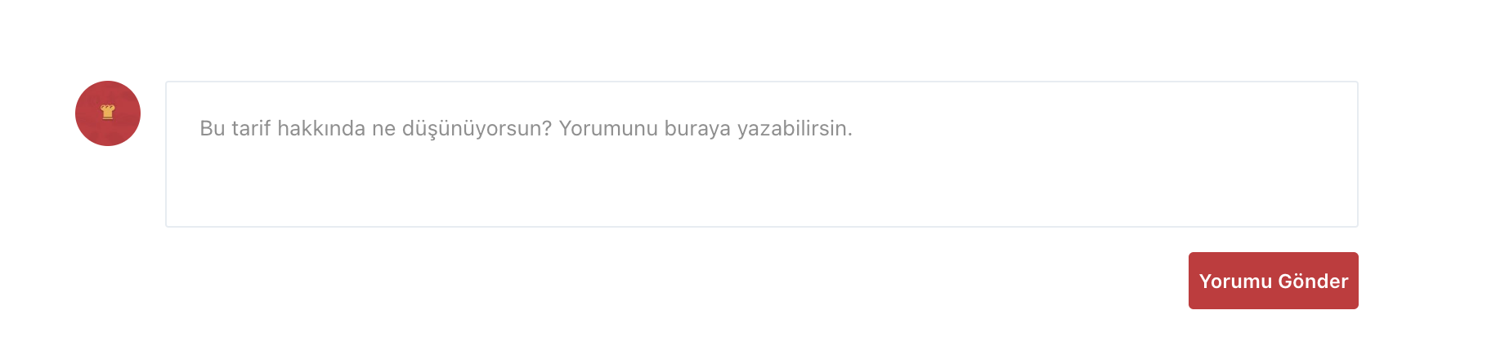

14. Click on the comment field.

15. Write a comment in the comment field.

**Input:** Elinize sağlık

16. Click on the "Yorumu Gönder" button.

**Expected Result:** The submitted comment should appear under the "Yeni Gelen Yorumlar" section.

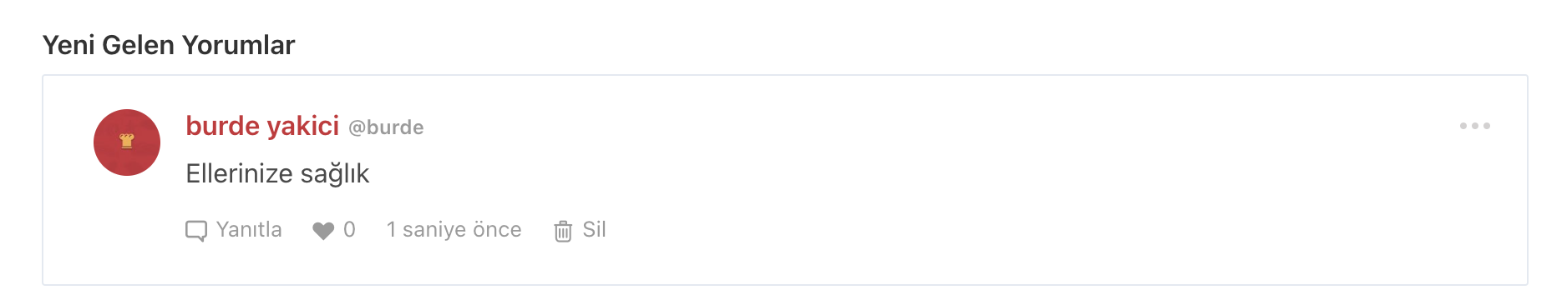

**2. Test Scenario Name:** **Saving Favorite Recipes and Displaying the Favorite Recipes List Correctly.**

**Description:** Testing the ability of users to save favorite recipes on the Recipe Platform and verifying the correct display of the favorite recipes list.

**Prerequisites:** The test environment must be operational and ready.

**Case 1:** **Ability to Save Favorite Recipe Without User Login**

**Description:** Testing whether the user can save favorite recipes on the website without logging in.

**Preconditions:** The test environment must be operational and ready.

**Steps:**

1. Open the browser.
2. Go to<https://www.nefisyemektarifleri.com/> URL.
3. Click on the "TARİFLER" heading on the homepage.
4. Click on one of the listed categories.

**Input:** Bakliyat Yemekleri

1. Click on one of the listed recipes.

**Input:** İçli Köfte Tarifi

1. Click on the "Deftere Ekle" heading below the recipe image.

**Expected Result:** The "Giriş Yap" page should open on the screen, and it should not allow saving the recipe without logging in.

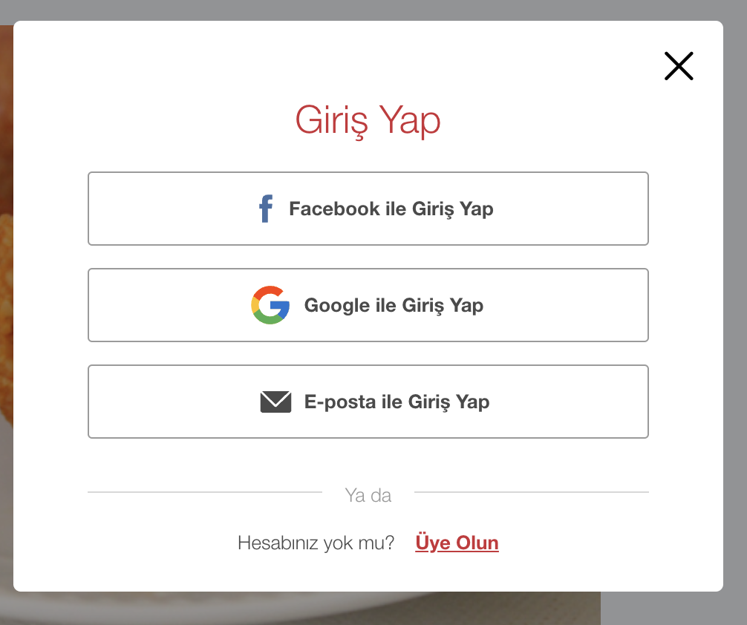

**Case 2: Verifying User's Ability to Save Favorite Recipes by Logging In and Checking the Favorite Recipes List**

**Description:** Testing the user's ability to save a favorite recipe on the website by logging in, and verifying the accuracy of the list of favorite recipes.

**Preconditions:** The test environment should be operational and ready.

**Steps:**

1. Open the browser.
2. Go to<https://www.nefisyemektarifleri.com/> URL.
3. Hover over the "Giriş Yap" icon.
4. Click on the "Giriş Yap” link.
5. Click on the desired login method.

**Input:** E-posta ile Giriş Yap

1. Enter the username or email address into the Username / Email field.

**Input:** brdykc@hotmail.com

1. Enter the password into the Password field.

**Input:** 123456

1. Click on the "Giriş Yap" button.

**Expected Result:** The page should display "Giriş başarılı. Yönlendiriliyorsunuz.." message at the bottom.



9. Click on the "TARİFLER" heading on the homepage.

10. Click on one of the listed categories.

**Input:** Bakliyat Yemekleri

11. Click on one of the listed recipes.

**Input:** İçli Köfte Tarifi

12. Click on the "Deftere Ekle" heading below the recipe image.

**Expected Result**: At the bottom of the page, the text "Tarif defterinize eklendi" should be displayed. The text below the recipe image that previously said "Deftere Ekle" should now say "Deftere Ekli"



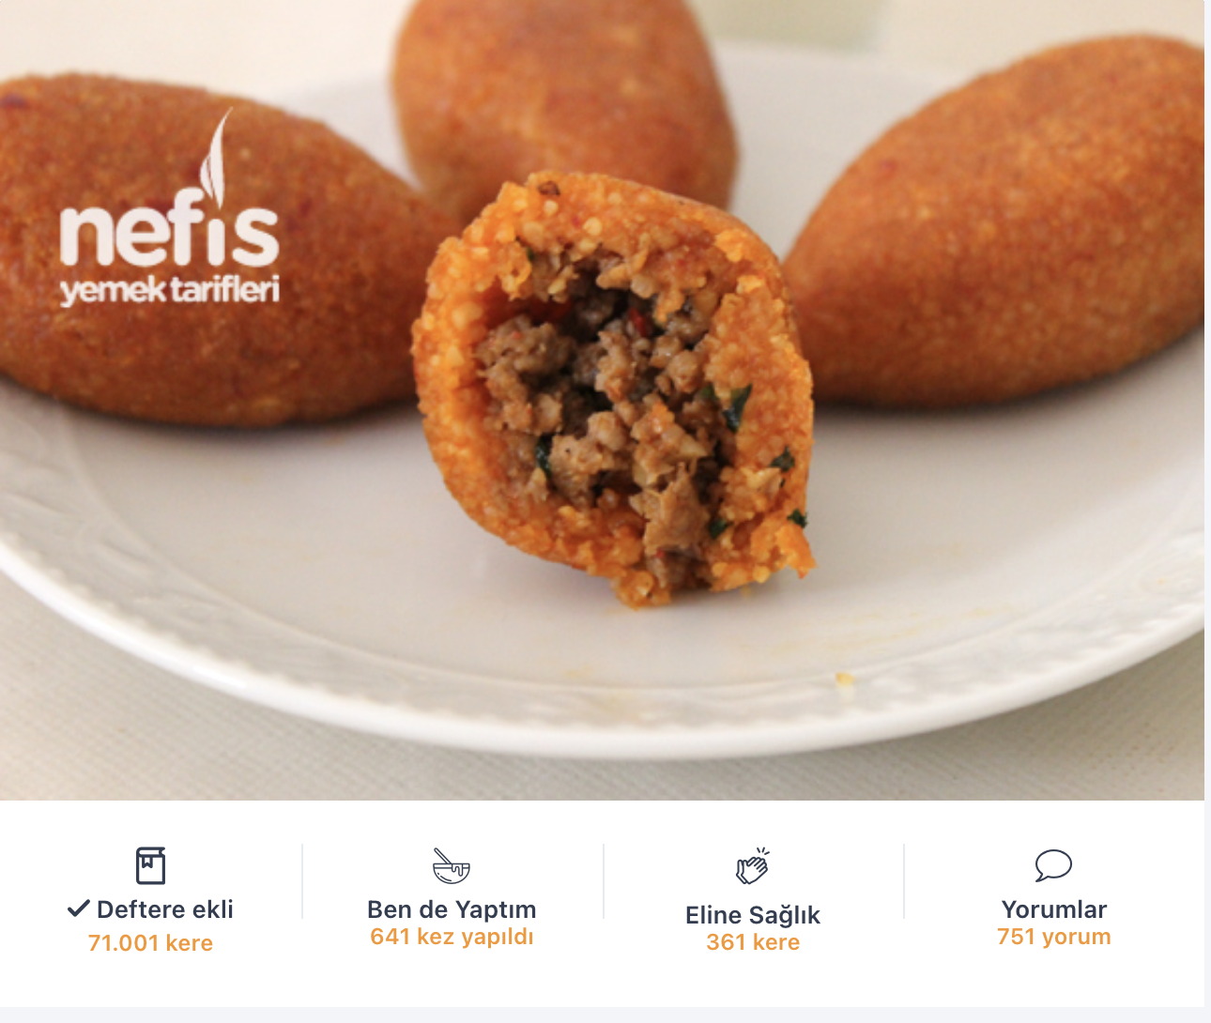

13. Hover over the profile area in the top right corner of the page.

14. Click on "Tarif Defterim".

15. Click on the "Tarif Defteri" area.

**Expected Result:** The recipes saved in the recipe book should be displayed in this area.

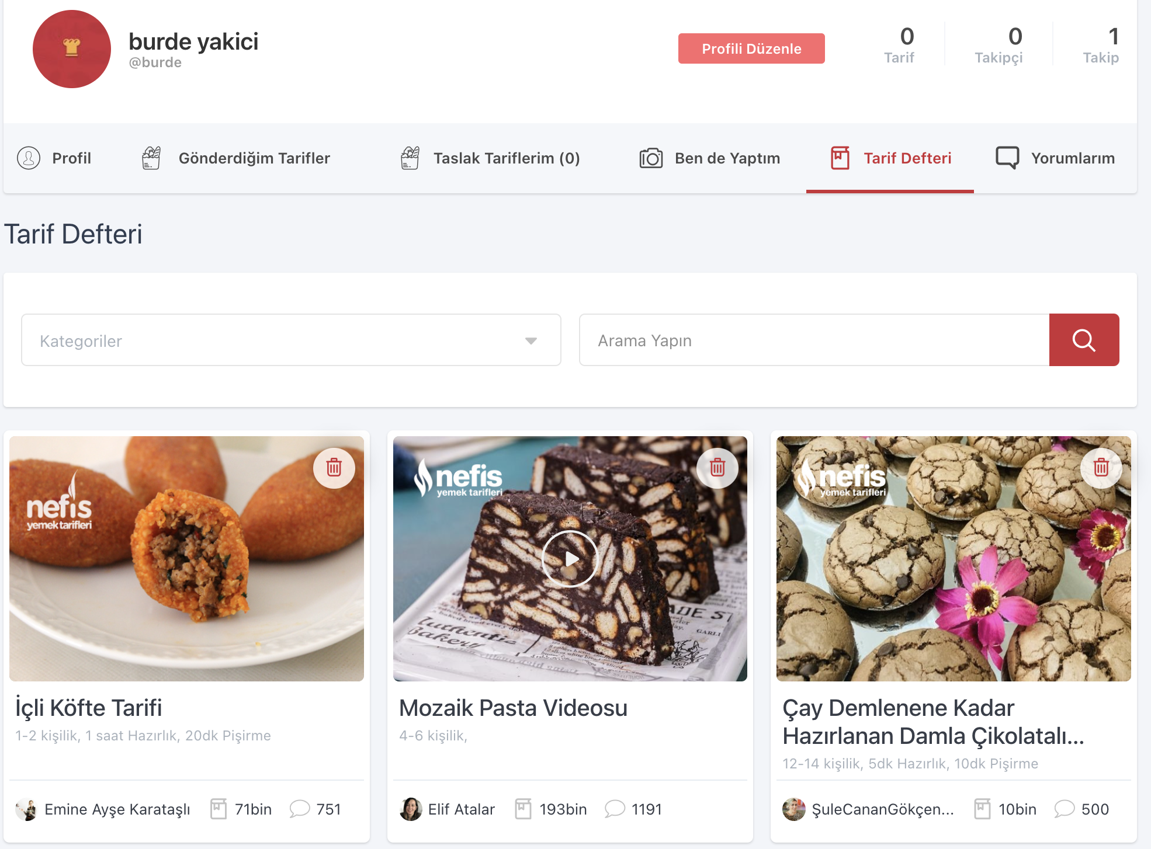

**3. Test Scenario: Verification of Comment and Favorite Recipe Management or Deletion**

**Description:** Verification of the correctness of operations for managing or deleting comments and favorite recipes on the Recipe Website.

**Preconditions:** The test environment must be operational and ready. The user must be logged into the system.

**Case 1:** **Verification of Editing or Deleting Comments via User Profile**

**Description:** Testing the ability of users to edit or delete their comments through the profile area.

**Preconditions:** The test environment must be operational and ready. The user must be logged into the system. The recipe to be deleted must have been previously added. **Steps:**

1. Open the browser.
2. Go to<https://www.nefisyemektarifleri.com/>.
3. Hover over the area displaying the username.
4. Click on the "Yaptığım Yorumlar" section.
5. Click on the "Sil" button under the comment you want to delete.

**Expected Result:** A confirmation window titled "Yorumu silmek istediğinizden emin misiniz?" should open.

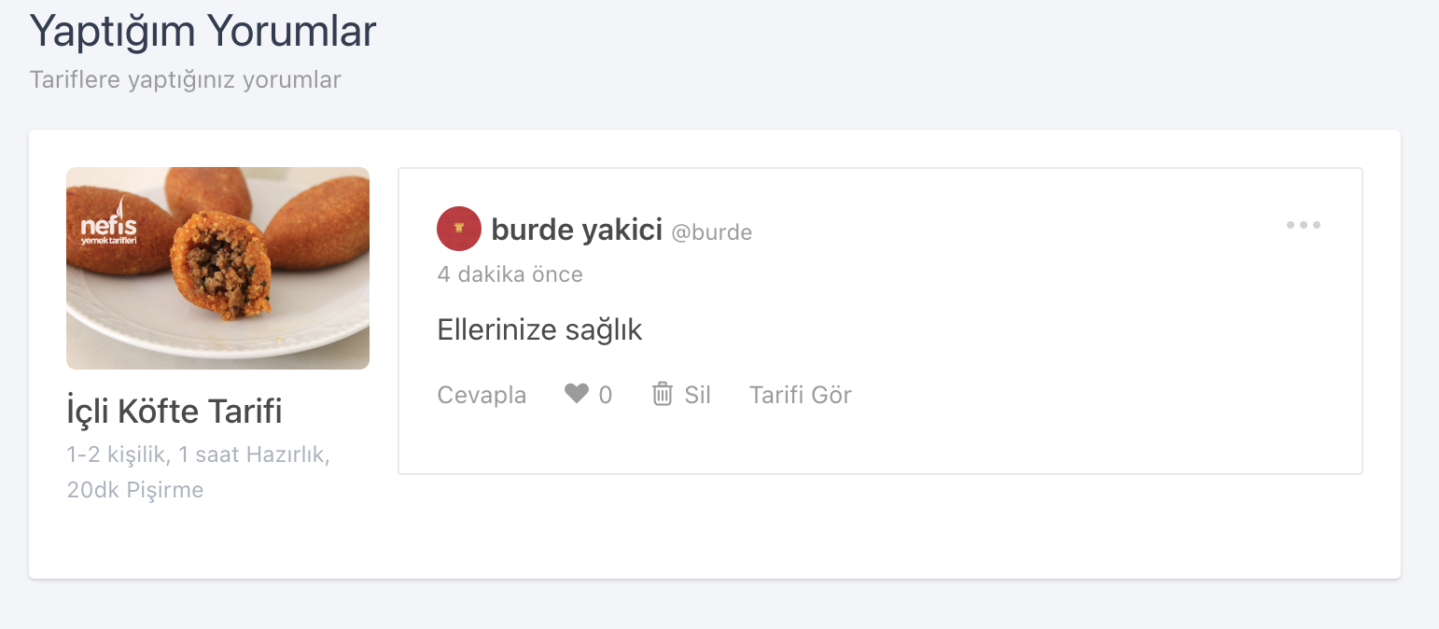

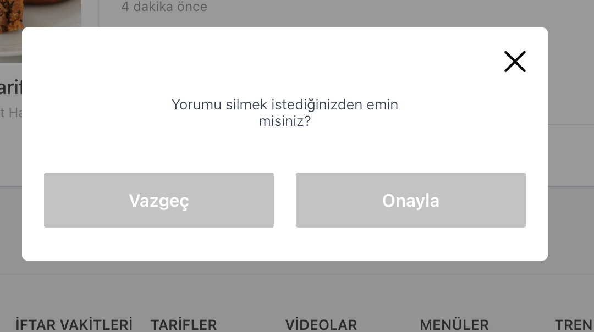

1. Click on the "Onayla" button.

**Expected Result:** There should be no comments in the "Yaptığım Yorumlar" section. At the bottom of the page, the text "Yorum başarılı bir şekilde silindi" should be visible.



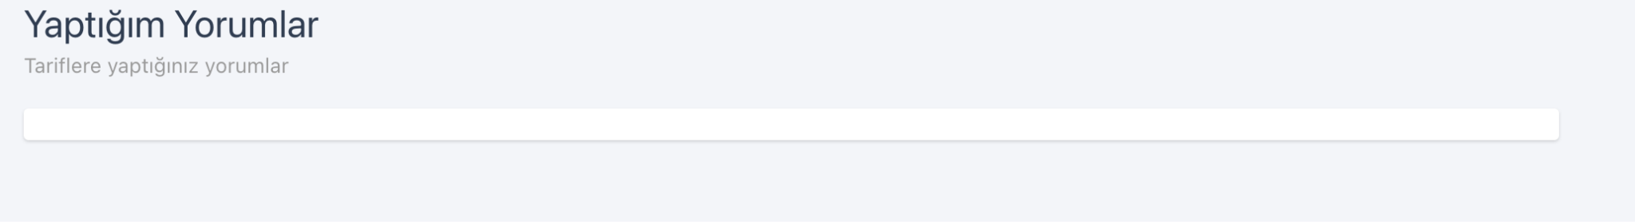

**Case 2:** **Verification of Deleting Favorite Recipes**

**Description:** Verification of the user's ability to delete favorite recipes.

**Preconditions:** The test environment must be operational and ready. The user must be logged into the system.

**Steps:**

1. Open a web browser.
2. Go to<https://www.nefisyemektarifleri.com/>.
3. Hover over the area where the username is displayed.
4. Click on the "Tarif Defterim" title.
5. Click on the "Tarif Defteri" section.
6. On the opened page, click on the delete icon located in the top right corner of the recipe to be deleted.

**Expected Result:** At the bottom of the page, the text "Defterden başarılı bir şekilde çıkarıldı." should be displayed. The recipe should be removed from "Tarif Defterim".

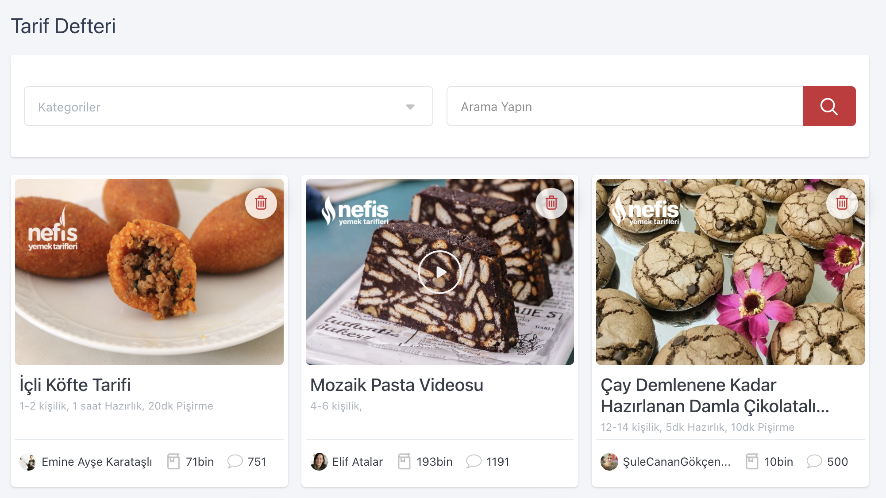

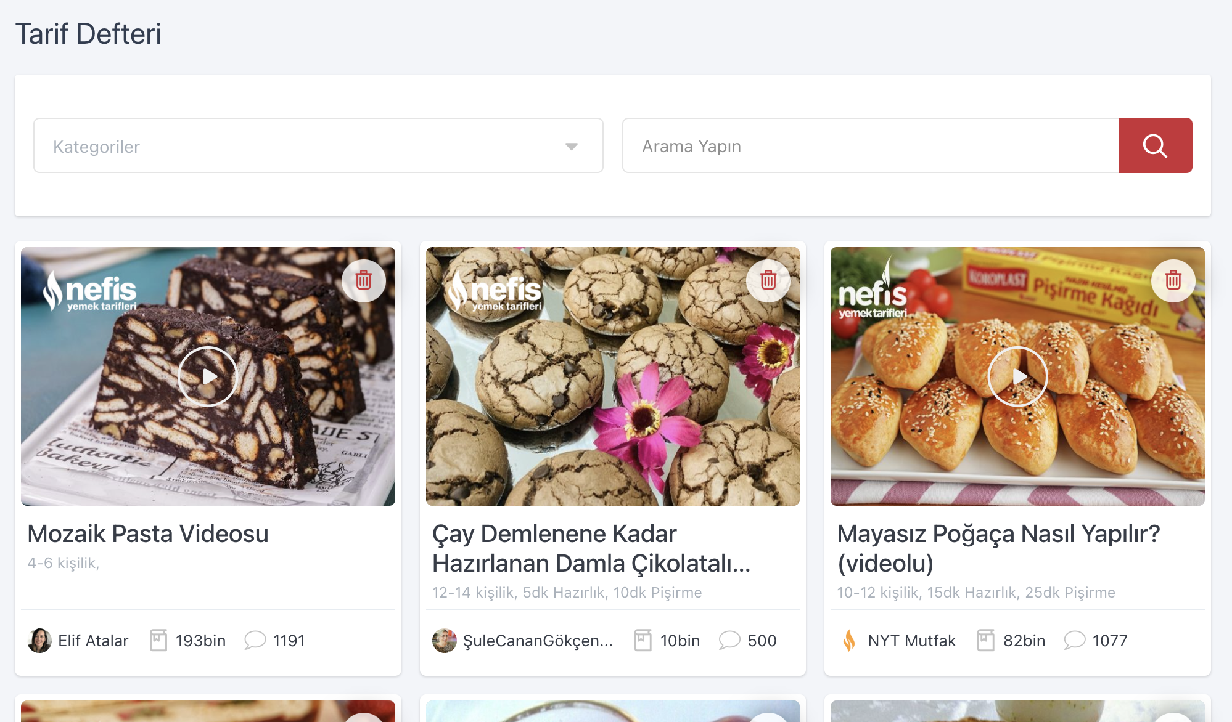

**BUG REPORTS**

**Bug 1: Checking the Ingredient Filtering Area by Clicking on the Search Icon**

**Description:** When the user clicks on the search icon to filter recipes based on ingredients they do not want, the returned results may contain ingredients that should not be in the recipe content.

**Preconditions:** The test environment must be operational and ready.

**Steps:**

1. Open the browser.
2. Go to<https://www.nefisyemektarifleri.com/>.
3. Click on the search icon on the homepage.

**Expected Result:** There should be filtering areas titled "Tarif bu malzemeleri içersin:" and "tarif bu malzemeleri içermesin:" .

1. Click on the "Tarif bu malzemeleri içersin:" area and enter an ingredient you want to include in the recipe.

**Input:** Peynir

1. Click on the resulting recipe.
2. Click on the "Tarif bu malzemeyi içermesin:" area and enter an ingredient you do not want in the recipe.

**Input:** Maya

1. Click on the resulting recipe.
2. Click on the "Arama Yap"button.

**Expected Result:** Recipes containing "peynir" and not containing "maya" should be listed.

**Actual Result:** Recipes containing "maya" are also listed.

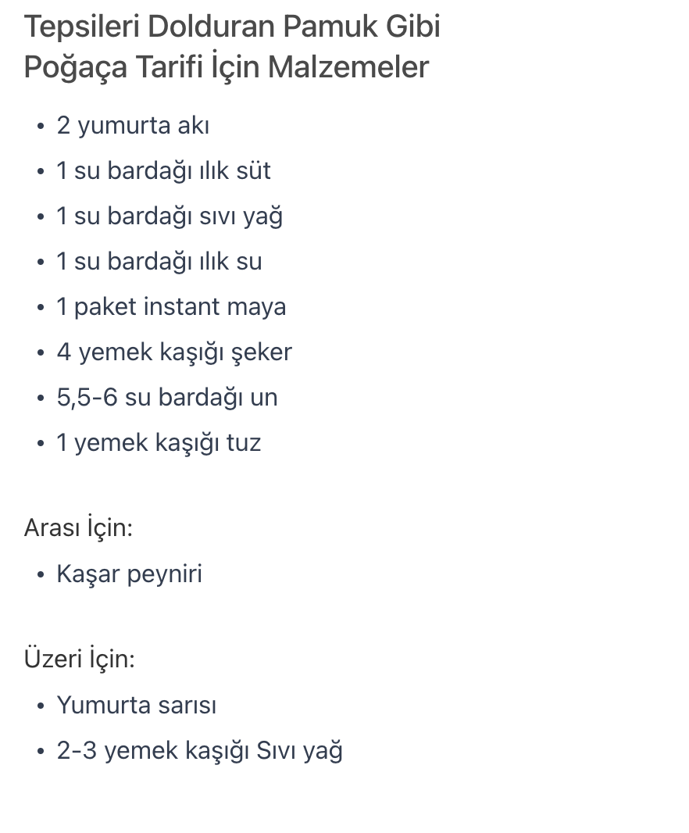

**Bug 2: Verification of Editing or Deleting Comments from the User Profile**

**Description:** When testing the user's ability to edit or delete comments from their profile, it was found that only deletion is allowed; there is no editing feature available.

**Preconditions:** The test environment must be operational and ready. The user must be logged into the system.

**Steps:**

1. Open the browser.
2. Go to<https://www.nefisyemektarifleri.com/> URL.
3. Hover over the area with the username.
4. Click on the "Yaptığım Yorumlar" heading.
5. Click on the "Sil" link below the comment you want to manage.

**Expected Result:** A confirmation window "Yorumu silmek istediğinizden emin misiniz?" should appear.

1. Click on the "Onayla" button.

**Expected Result:** There should be no comments listed in the "Yaptığım Yorumlar" section.

**Actual Result:** There are no comments found in the "Yaptığım Yorumlar" section. While it allows for deleting comments, there is currently no functionality available for editing comments.

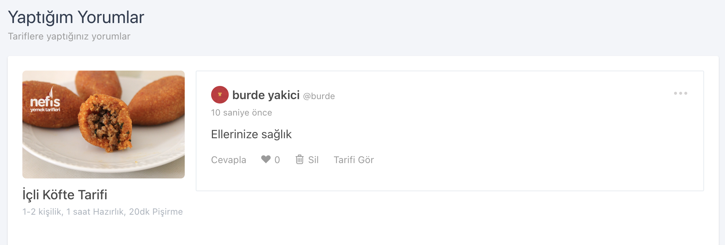

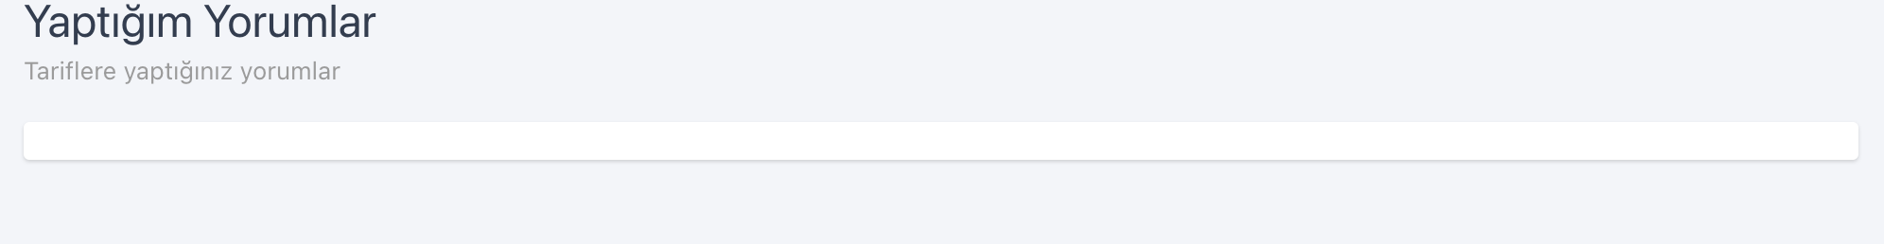

**Bug 3: Verification of Recipe Deletion from Recipe Book**

**Description:** When a user deletes a recipe from their recipe book, the page displays an incorrect success message.

**Preconditions:** The test environment must be operational and ready. The user must be logged into the system.

**Steps:**

1. Open the browser.
2. Go to the URL<https://www.nefisyemektarifleri.com/>.
3. Hover over the area where the username is displayed.
4. Click on the "Tarif Defterim" title.
5. Click on the "Tarif Defteri" section.
6. On the opened page, click on the delete icon located at the top right corner of the recipe to be deleted.

**Expected Result:** A confirmation window should open with the message "Yorumu silmek istediğinizden emin misiniz?".

7. Click on the "Onayla " button.

**Expected Result:** The message "Defterden başarılı bir şekilde çıkarıldı." should be displayed at the bottom of the page, and the recipe should be removed from the "Tarif Defterim" section.

**Actual Result:** The message "Deftereden başarılı bir şekilde çıkarıldı" is displayed at the bottom of the page.

